液压启闭设备业绩表
Hydraulic Opening and Closing Equipment Achievement
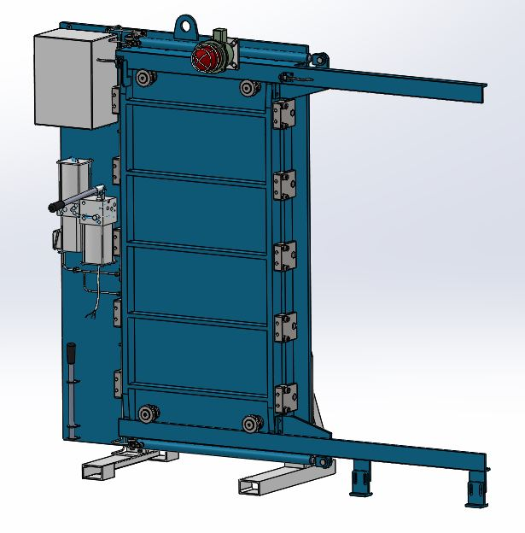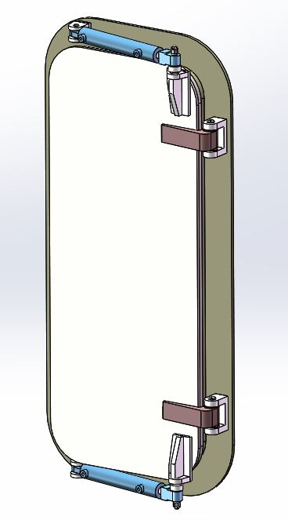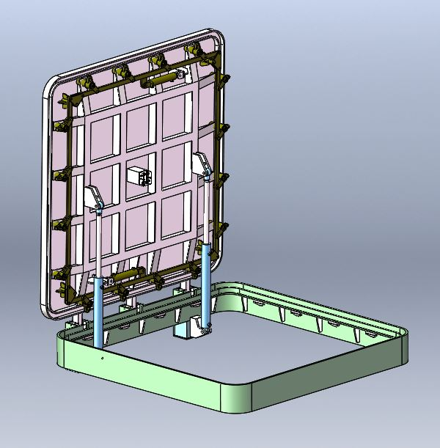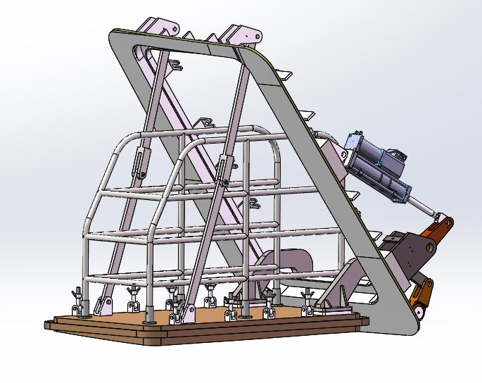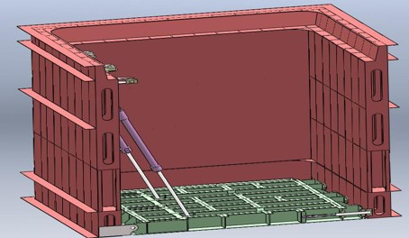

无锡市东舟船舶设备股份有限公司
Wuxi Dongzhou Marine Equipment Co. LTD.
船 用 液 压 滑 动 水 密 门 业 绩 表
Marine Hydraulic Sliding Watertight Door Achievement
序号  No. | 船 厂  Shipyard | 船名/船号  Hull name/Hull No. | 型 号  Item No. | 型 式  Type | 数量  QTY | 船检  Ship Survey | 船 东  Owner
1 | 中国烟台莱佛士船厂  CIMC Raffles shipyard | PROA2000 | 262WDF015 |  | 3船套  3ship/sets | ABS
2 | 江苏扬子江船厂有限公司  Jiangsu Yangzijiang Shipyard Co. LTD | 6000HP油田守护船(1-3号船)  6000HP oil field guardianship(1-3 ship) | 262WDF015 |  | 3船套  3ship/sets | CCS
3 | 江苏扬子江船厂有限公司  Jiangsu Yangzijiang Shipyard Co. LTD | 10000KW多功能守护船  10000KW multi-function stand-by vessel | 262WDF015 |  | 2船套  2ship/sets | CCS
4 | 杭州东风船舶制造有限公司  Hangzhou Dongfeng shipbuilding Co., Ltd. | 2880千瓦海洋拖轮  2880 kw ocean tug | 262WDF015 |  | 3船套  3ship/sets | CCS
5 | 武昌造船厂  Wuchang Shipbuilding Industry group Co.,Ltd. | 6500马力多功能守护船  6500 horsepower multi-purpose stand-by vessel | 262WDF015 |  | 12船套  12ship/sets | CCS
6 | 武昌造船厂  Wuchang Shipbuilding Industry group Co.,Ltd. | 6000HP电力推进守护船  6000HP electric propulsion stand-by vessel | 262WDF015 |  | 3船套  3ship/sets | CCS
7 | 芜湖船厂  Wuhu Shipbuilding Co., Ltd. | 6500HP油田守护船  6500HP oil field stand-by vessel | 262WDF015 |  | 5船套  5ship/sets | CCS
8 | 吴淞船厂  Wusong Shipyard | 552客客货轮  552 passenger passenger cargo ship | 262WDF015 |  | 1船套  1ship/set | LR
船 用 液 压 滑 动 水 密 门 业 绩 表
Marine Hydraulic Sliding Watertight Door Achievement
序号  No. | 船 厂  Shipyard | 船名/船号  Hull name/Hull No. | 型 号  Item No. | 型 式  Type | 数量  QTY | 船检  Ship Survey | 船 东  Owner
9 | 广州文冲船厂  Guangzhou Wenchong Shipyard Co.,Ltd | 1000m3 挖泥船  1000 m3 dredger | 262WDF015 |  | 1船套  1ship/set | CCS
10 | 广州文冲船厂  Guangzhou Wenchong Shipyard Co.,Ltd | 5000m3挖泥船  5000m3 dredger | 262WDF015 |  | 1船套  1ship/set | CCS
11 | 天津新港船厂  Tianjin Xingang shipbuilding Industry Co.,Ltd | 7000吨多用途集装箱船  7,000 tons multi-purpose container ships | 262WDF015 |  | 2船套  2ship/sets | GL
12 | 黄海船厂  Huanghai Shipyard | 8000马力多功能守护船  8000 horsepower multi-purpose stand-by vessel | 262WDF015 |  | 3船套  3ship/sets | CCS
13 | 黄海船厂  Huanghai Shipyard | 4000HP回转拖轮  4000HP rotary tug | 262WDF015 |  | 2船套  2ship/sets | CCS
14 | 人民解放军第四八零八工厂  People's liberation army 4808 factory | 60T拖轮  60T tug | 262WDF015 |  | 24船套  24ship/sets | ABS
15 | 上海振华重工股份有限公司  Shanghai Zhenhua Heavy Industry Co. LTD | 铺管船  Pipe-laying ship | 262WDF015 |  | 18船套  18ship/sets | LR
16 | 南通通德船舶修造有限公司  Nantong Tongde Ship repairing Co. LTD | KUBER | 262WDF015 |  | 6船套  6ship/sets | ABS

船 用 液 压 滑 动 水 密 门 业 绩 表
Marine Hydraulic Sliding Watertight Door Achievement
序号  No. | 船 厂  Shipyard | 船名/船号  Hull name/Hull No. | 型 号  Item No. | 型 式  Type | 数量  QTY | 船检  Ship Survey | 船 东  Owner
17 | 南通中远船务  Nantong Cosco shipping | SEVAN650 | 262WDF015 |  | 7船套  7ship/sets | DNV
18 | 广州航通船业有限公司  Guangzhou Hangtong Shipbuilding Co. LTD | 83.6米海洋工作居住（HT122205-06)  83.6m marine working and living (HT122205-06) | 262WDF015 |  | 10船套  10ship/sets | ABS
19 | 广船国际股份有限公司  Guangzhou Shipyard International Co.,Ltd | 海口海安线客滚船3#4#  Haikou Haian line ro-ro passenger ship 3#4# | 262WDF015 |  | 18船套  18ship/sets | CCS
20 | 福建省东南造船厂  Fujian South East Shipyard | 65M-DN65M-3/5sk500-506 | 262WDF015 |  | 60船套  60ship/sets | ABS
21 | 福建省东南造船厂  Fujian South East Shipyard | dn75m-16-19、78M-9/10 | 262WDF015 |  | 12船套  12ship/sets | ABS
22 | 南通中远船厂  Nantong Cosco shipping | 150000T | 262WDF015 |  | 8船套  8ship/sets | LR
23 | 招商局（深圳）有限公司  CMHI(Shenzhen) Co.,Ltd. | 4500方绞吸式挖泥船  4500m3 cutter suction dredger | 262WDF015 |  | 2船套  2ship/sets | CCS
24 | 招商局（深圳）有限公司  CMHI(Shenzhen) Co.,Ltd. | 广州打捞局12000KW海洋拖船  Guangzhou salvage bureau 12000KW marine tug | 262WDF015 |  | 4船套  4ship/sets | CCS
25 | 马来西亚郫骚船厂  Malaysia Pisao shipyard | 登陆舰  Landing ship | 262WDF015 |  | 1船套  1ship/set | BV

船 用 液 压 滑 动 水 密 门 业 绩 表
Marine Hydraulic Sliding Watertight Door Achievement
序号  No. | 船 厂  Shipyard | 船名/船号  Hull name/Hull No. | 型 号  Item No. | 型 式  Type | 数量  QTY | 船检  Ship Survey | 船 东  Owner
26 | 上海振华港机  Shanghai Zhenhua Heavy Industry Co. LTD | DLV4400 | 262WDF015 |  | 3船套  3ship/sets | ABS
27 | 福建马尾造船股份有限公司  Fujian Mawei shipbuilding Co., LTD | 320E LIFE BOAT（H0706B) | 262WDF015 |  | 5船套  5ship/sets | ABS
28 | 福建马尾造船股份有限公司  Fujian Mawei shipbuilding Co..LTD | MMC 879 PSV (H1009) | 262WDF015 |  | 6船套  6ship/sets | ABS
29 | 靖江南洋船舶制造有限公司  Jingjiang Nanyang Shipbuilding Co., Ltd | 65M（H1405/1406） | 262WDF015 |  | 14船套  14ship/sets | ABS
30 | 青岛武船重工有限责任公司  Qingdao Wuchuan Heavy Industry Co. LTD | 10000T深潜水工作母船  10000T deep diving working mother ship | 262WDF015 |  | 14船套  14ship/sets | CCS
31 | 靖江南洋船舶制造有限公司  Jingjiang Nanyang Shipbuilding Co., Ltd | 120米铺管工程船（H1454）  120M pipe-laying engineering ship (H1454) | 262WDF015 |  | 8船套  8ship/sets | ABS
32 | 中交博迈科海洋船舶公司  CCCC BOMESC Marine Industry Co., Ltd. | 13000T甲板货船  13000T deck cargo ship | 262WDF015 |  | 2船套  2ship/sets | ABS
33 | 中交博迈科海洋有限公司  CCCC BOMESC Marine Industry Co., Ltd. | 20000T半潜船  20000T Semi-submersible vessel | 262WDF015 |  | 7船套  7ship/sets | CCS

船 用 液 压 滑 动 水 密 门 业 绩 表
Marine Hydraulic Sliding Watertight Door Achievement
序号  No. | 船 厂  Shipyard | 船名/船号  Hull name/Hull No. | 型 号  Item No. | 型 式  Type | 数量  QTY | 船检  Ship Survey | 船 东  Owner
34 | 广东广机海事重工有限公司  Guangdong Guangji Marine Heavy Industry Co. LTD | 78M多功能支持船  78M multi-function support ship | 262WDF015 |  | 22船套  22ship/sets | ABS
35 | 宏华海洋油气装备有限公司  Honghua offshore oil and gas Equipment Co., LTD | 83米平台供应船  83m platform supply ship | 262WDF015 |  | 3船套  3ship/sets | ABS
36 | 广州航通船业有限公司  Guangzhou Hangtong shipbuilding Co., LTD | 85M-1-2/76M-1-2 | 262WDF015 |  | 10船套  10ship/sets | ABS
37 | 福建省东南造船厂  Fujian South East Shipyard | 75米钻井平台供应SK705-708,18  75m drilling platform supplies | 262WDF015 |  | 15船套  15ship/sets | ABS
38 | 福建省东南造船厂  Fujian South East Shipyard | 60M操锚供应拖船(1.2.3.5.6.7)  60M anchor handling supply tug (1.2.3.5.6.7) | 262WDF015 |  | 24船套  24ship/sets | ABS
39 | 南通中远船务工程有限公司  Nantong Cosco Shipping | 350people | 262WDF015 |  | 8船套  8ship/sets | ABS
液压滑动水密门从2001年起至今已供货1万多余套
More than 10,000 sets of hydraulic sliding watertight doors have been delivered since 2001

船 用 液 压 舱 口 盖 业 绩 表
Marine Hydraulic Hatch cover Achievement
序号  No. | 船 厂  Shipyard | 船名/船号  Hull name/Hull No. | 型 号  Item No. | 型 式  Type | 数量  QTY | 船检  Ship Survey | 船 东  Owner
1 | 江苏熔盛重工  Jiangsu Rongsheng Heavy Industry Co., Ltd | H1088铺管船  H1088 pipe laying ship | 263WDF009 |  | 1船套  1ship/set | CCS
2 | 江苏招商重工  Jiangsu Merchants Heavy Industry Co., Ltd. | 163-1\2 | 263WDF009 |  | 2船套  2ship/sets | ABS
3 | 广州中船黄埔造船有限公司  Guangzhou CSSC Huangpu Shipyard Co.,Ltd. | 海洋石油 offshore oil 286 H3039 | 263WDF009 |  | 2船套  2ship/sets | CCS
4 | 旅顺滨海船舶修造有限公司  Lushun Binhai Ship Repairing Co. LTD | 37.8m拖网渔船  37.8m trawler | 263WDF009 |  | 2船套  2ship/sets | ZY
5 | 上海船厂船舶有限公司  Shanghai shipyard Co., Ltd. | 海洋石油offshore oil 721 S8003 | 263WDF009 |  | 6船套  6ship/sets | ZY
6 | 烟台北方造船有限公司  Yantai Beifang shipbuilding co. LTD | 37.8m拖网渔船  37.8m trawler | 263WDF009 |  | 2船套  2ship/sets | CCS
7 | 舟山和泰船舶修造有限公司  Zhoushan Hetai shipbuilding Co., Ltd. | 300吨近海渔业资源调查船  300 tons offshore fishery resources survey ship HS8023 | 263WDF009 |  | 3船套  3ship/sets | CCS
8 | 中船黄埔文冲船舶有限公司  CSSC Huangpu Wenchong Shipbuilding Company Limited | DSV-246 潜水支持船diving support vessel H3080 | 263WDF009 |  | 5船套  5ship/sets | CCS
9 | 浙江造船有限公司  Zhejiang shipbuilding Co. LTD | 300吨渔业资源调查船 300 tons fishery resources survey ship J5001-5 | 263WDF009 |  | 2船套  2ship/sets | ZY
10 | 中船黄埔文冲船舶有限公司  CSSC Huangpu Wenchong Shipbuilding Company Limited | 南海科考船  South sea research vessel | 263WDF009 |  | 5船套  5ship/sets | CCS
船 用 液 压 艏 门 业 绩 表
Marine Hydraulic bow door Achievement
序号  No. | 船 厂  Shipyard | 船名/船号  Hull name/Hull No. | 型 号  Item No. | 型 式  Type | 数量  QTY | 船检  Ship Survey | 船 东  Owner
1 | 广州黄埔文冲船厂  Guangzhou Huangpu Wenchong Shipbuilding Company Limited | 701、702 | 262WDF018 |  | 2船套  2ship/sets | CCS
2 | 广州黄埔文冲船厂  Guangzhou Huangpu Wenchong Shipbuilding Company Limited | 海洋石油offshore oil 286 | 262WDF018 |  | 2船套  2ship/sets | CCS
3 | 广新海事重工股份有限公司  Guangxin Marine heavy industry Co.,LTD | 6000HP1-6# | 262WDF018 |  | 2船套  2ship/sets | CCS
4 | 振华港机  Shanghai Zhenhua Heavy Industry Co. LTD | 6000HP1-4# | 262WDF018 |  | 2船套  2ship/sets | CCS
5 | 大连中远  Dalian Cosco shipping | SSV1-3# | 262WDF018 |  | 3船套  3ship/sets | LR
6 | 大连中远  Dalian Cosco shipping | 624、625、626 | 262WDF018 |  | 3船套  3ship/sets | LR
7 | 江新同方  Jiangxin Tongfang Shipbuilding Co., Ltd. | 6500HP | 262WDF018 |  | 2船套  2ship/sets | CCS
8 | 上海船厂  Shanghai shipyard Co., Ltd. | 8002、8004 | 262WDF018 |  | 2船套  2ship/sets | CCS
9 | 福建马尾造船股份有限公司  Fujian Mawei shipbuilding Co., LTD | 8000HP深水三用工作船  8000HP deep water working vessel MW633-1/2 | 262WDF018 |  | 2船套  2ship/sets | CCS

船 用 液 压 艏 门 业 绩 表
Marine Hydraulic bow door Achievement
序号  No. | 船 厂  Shipyard | 船名/船号  Hull name/Hull No. | 型 号  Item No. | 型 式  Type | 数量  QTY | 船检  Ship Survey | 船 东  Owner
10 | 上海振华重工股份有限公司  Shanghai Zhenhua Heavy Industry Co. LTD | 4500T大型抢险打捞起重船  4500T large salvage crane | 262WDF018 |  | 1船套  1ship/set | CCS
11 | 广新海事重工股份有限公司  Guangxin Marine heavy industry Co.,LTD | 8000HP破冰三用工作船  8000HP ice breaker AHTS GS15154-7 | 262WDF018 |  | 3船套  3ship/sets | CCS
液压艏门从2001年至今已供货300多余套
More than 300 sets of hydraulic bow doors have been delivered since 2001

其 他 船 用 液 压 启 闭 设 备 业 绩 表
other Marine Hydraulic opening and closing Achievement
序号  No. | 船 厂  Shipyard | 船名/船号  Hull name/Hull No. | 型 号  Item No. | 型 式  Type | 数量  QTY | 船检  Ship Survey | 船 东  Owner
1 | 黄海船厂  Huanghai Shipyard | 威大客滚轮  Weida passenger ship | 旅客门  Passenger door |  | 2船套  2ship/sets | CCS
2 | 黄海船厂  Huanghai Shipyard | 烟大客滚轮  Yanda passenger ship | 船员门  Crew door |  | 2船套  2ship/sets | CCS
3 | 上海江南船厂  Shanghai jiangnan shipyard | 新雪龙号  New Snow Dragon | CTD门  CTD door |  | 1船套  1ship/set | CCS
4 | 新加坡三巴旺船厂  Singapore Sanbawang shipyard | 南极科考船  Antarctic research vessel | CTD门  CTD door |  | 1船套  1ship/set | LR
5 | 广州黄埔文冲船厂  Guangzhou Huangpu Wenchong Shipbuilding Company Limited | MMC887MPSV | 月池底门  Moon pool bottom door |  | 1船套  1ship/set | ABS
6 | 黄海船厂  Huanghai Shipyard | 烟大客滚轮  Yanda passenger ship | 船员门  Crew door |  | 2船套  2ship/sets | CCS
7 | 广州广船国际股份有限公司  Guangzhou Shipyard International Co.,Ltd | 46车/900客客滚船  46 cars /900 passengers ship | 旅客门  Passenger door |  | 4船套  4ship/sets | CCS
8 | 黄海船厂  Huanghai Shipyard | 800客位客箱船  800 passenger container ships | 旅客门  Passenger door |  | 2船套  2ship/sets | CCS
9 | 黄海船厂  Huanghai Shipyard | 800客位客箱船  800 passenger container ships | 加油站门  Gas station door |  | 3船套  3ship/sets | CCS
10 | 黄海船厂  Huanghai Shipyard | 800客位客箱船  800 passenger container ships | 船员门  Crew door |  | 2船套  2ship/sets | CCS

其 他 船 用 液 压 启 闭 设 备 业 绩 表
other Marine Hydraulic opening and closing Achievement
序号  No. | 船 厂  Shipyard | 船名/船号  Hull name/Hull No. | 型 号  Item No. | 型 式  Type | 数量  QTY | 船检  Ship Survey | 船 东  Owner
11 | 口岸船厂  Taizhou Kouan shipbuilding Co.,Ltd. | 紫荆十二  Redbud 12# | 旅客门  Passenger door |  | 2船套  2ship/sets | CCS
12 | 口岸船厂  Taizhou Kouan shipbuilding Co.,Ltd. | 紫荆十二  Redbud 12# | 船员门  Crew door |  | 2船套  2ship/sets | CCS
13 | 江苏熔盛重工  Jiangsu Rongsheng Heavy Industry Co., Ltd | H1088铺管船  H1088 pipe laying ship | 铺管门  Pipe laying door |  | 2船套  2ship/sets | CCS
14 | 振华港机  Shanghai Zhenhua Heavy Industry Co. LTD | 4400T铺管船  4400T pipe laying ship | 铺管门  Pipe laying door |  | 2船套  2ship/sets | GL
15 | 振华港机  Shanghai Zhenhua Heavy Industry Co. LTD | 4400T铺管船  4400T pipe laying ship | 艉门  Stern door |  | 1船套  1ship/set | GL
16 | 口岸船厂  Taizhou Kouan shipbuilding Co.,Ltd. | 北海-涠洲岛客船  Beihai - Weizhou Island passenger ship | 旅客跳板  Passengers board |  | 2船套  2ship/sets | CCS
17 | 上海船厂  Shanghai shipyard Co., Ltd. | 8002、8004 | 舷门  Shell door |  | 4船套  4ship/sets | CCS
18 | 江苏熔盛重工  Jiangsu Rongsheng Heavy Industry Co., Ltd | H1088铺管船  H1088 pipe laying ship | 铺管门  Pipe laying door |  | 2船套  2ship/sets | CCS
其他液压设备从2001年至今已供货600多余套
More than 600 sets of other hydraulic equipment have been delivered since 2001

